Aplicación 2.9: Producción empresarial

J. Ramajo

2020

En este ejercicio se analizará el proceso productivo de un conjunto de empresas, utilizando una muestra de corte transversal compuesta por 814 compañías para las que se dispone de información sobre la producción, el número de empleados y el stock de capital.

Para estudiar la relación entre el output, *Y*, y los dos inputs considerados, *L* y *K*, es habitual encontrar en la literatura a función de producción del tipo *Cobb*-*Douglas* (en honor de los investigadores que la propusieron, Charles Cobb y Paul Douglas), que viene dada por la expresión:

$$Y=AL^{α}K^{β}$$

siendo *A* una medida de eficiencia tecnológica y *α* y *β* las elasticidades de la producción respecto a cada uno de los inputs. Tras tomar logaritmos y añadir un término de error, se obtiene el siguiente modelo de regresión lineal:

$$logY_{i}=β_{1}+β_{2}\log{L_{i}+}β_{3}\log{K_{i}+}e_{i}$$

donde $β_{1}=\log{A}$, $β_{2}=α$ y $β_{3}=β$.

Una generalización de la función de Cobb-Douglas es la función de producción translogarítmica (*translog*), que viene dada por el modelo:

$$\log{Y_{i}}=β_{1}+β_{2}\log{L_{i}}+β_{3}\log{K_{i}}+β_{4}{\left(\log{L_{i}}\right)}^{2}+β_{5}{\left(\log{K_{i}}\right)}^{2}+β_{6}\left(\log{L_{i}}\right)\left(\log{K_{i}}\right)+e_{i}$$

Esta función de producción relaja la hipótesis de elasticidad de substitución unitaria impuesta por la función Cobb-Douglas, siendo esta última un caso particular al que se llega mediante la restricción $β_{4}=β_{5}=β_{6}=0$.

library(readr)  
library(car)

## Loading required package: carData

library(MASS)  
library(effects)

## Registered S3 methods overwritten by 'lme4':  
## method from  
## cooks.distance.influence.merMod car   
## influence.merMod car   
## dfbeta.influence.merMod car   
## dfbetas.influence.merMod car

## lattice theme set by effectsTheme()  
## See ?effectsTheme for details.

library(tidyverse)

## ── Attaching packages ──────────────────────────────────────────────────────────────────────────── tidyverse 1.3.0 ──

## ✓ ggplot2 3.3.1 ✓ dplyr 1.0.0  
## ✓ tibble 3.0.1 ✓ stringr 1.4.0  
## ✓ tidyr 1.1.0 ✓ forcats 0.5.0  
## ✓ purrr 0.3.4

## ── Conflicts ─────────────────────────────────────────────────────────────────────────────── tidyverse_conflicts() ──  
## x dplyr::filter() masks stats::filter()  
## x dplyr::lag() masks stats::lag()  
## x dplyr::recode() masks car::recode()  
## x dplyr::select() masks MASS::select()  
## x purrr::some() masks car::some()

library(gvlma)  
library(tseries)

## Registered S3 method overwritten by 'quantmod':  
## method from  
## as.zoo.data.frame zoo

library(stats)  
library(lmtest)

## Loading required package: zoo

##   
## Attaching package: 'zoo'

## The following objects are masked from 'package:base':  
##   
## as.Date, as.Date.numeric

#  
PROD_EMP <- read_csv("PROD_EMP.csv")

## Parsed with column specification:  
## cols(  
## K = col_double(),  
## L = col_double(),  
## Y = col_double()  
## )

head(PROD_EMP, n=10)

## # A tibble: 10 x 3  
## K L Y  
## <dbl> <dbl> <dbl>  
## 1 0.0102 3 0.0263  
## 2 0.0994 2 0.0811  
## 3 0.0139 3 0.129   
## 4 0.0900 4 0.273   
## 5 0.442 2 0.289   
## 6 0.243 5 0.350   
## 7 0.00223 2 0.386   
## 8 0.430 3 0.432   
## 9 0.669 8 0.454   
## 10 0.715 11 0.519

dim(PROD_EMP)

## [1] 569 3

summary(PROD_EMP)

## K L Y   
## Min. : 0.0022 Min. : 1.0 Min. : 0.0263   
## 1st Qu.: 0.9834 1st Qu.: 45.0 1st Qu.: 2.6663   
## Median : 2.1993 Median : 86.0 Median : 4.6026   
## Mean : 11.5154 Mean : 201.1 Mean : 14.7192   
## 3rd Qu.: 6.2146 3rd Qu.: 176.0 3rd Qu.: 9.7421   
## Max. :1786.8992 Max. :10661.0 Max. :1279.3717

#  
# Matriz 'scatterplot' de los datos

#  
scatterplotMatrix(~Y + L + K, data=PROD_EMP, var.labels=c("Producción", "Empleo", "Stock de capital"), col="black")

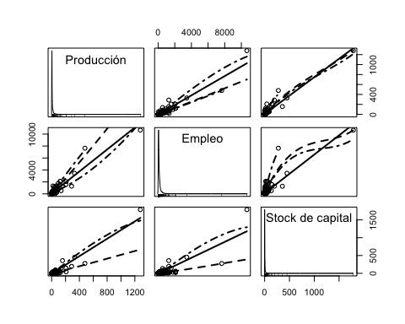

# Función Cobb-Douglas  
S(lm_cd <- lm(log(Y) ~ log(L) + log(K), data = PROD_EMP))

## Call: lm(formula = log(Y) ~ log(L) + log(K), data = PROD_EMP)  
##   
## Coefficients:  
## Estimate Std. Error t value Pr(>|t|)   
## (Intercept) -1.71146 0.09671 -17.70 <2e-16 ***  
## log(L) 0.71485 0.02314 30.89 <2e-16 ***  
## log(K) 0.20757 0.01719 12.08 <2e-16 ***  
## ---  
## Signif. codes: 0 '***' 0.001 '**' 0.01 '*' 0.05 '.' 0.1 ' ' 1  
##   
## Residual standard deviation: 0.4781 on 566 degrees of freedom  
## Multiple R-squared: 0.8378  
## F-statistic: 1462 on 2 and 566 DF, p-value: < 2.2e-16   
## AIC BIC   
## 779.89 797.27

confint(lm_cd)

## 2.5 % 97.5 %  
## (Intercept) -1.9014148 -1.5215040  
## log(L) 0.6693927 0.7603008  
## log(K) 0.1738111 0.2413295

#  
# Diagnósticos  
#  
# Validación general del modelo (gvlma)

#  
gvmodel <- gvlma(lm_cd)  
summary(gvmodel)

##   
## Call:  
## lm(formula = log(Y) ~ log(L) + log(K), data = PROD_EMP)  
##   
## Residuals:  
## Min 1Q Median 3Q Max   
## -1.7604 -0.2665 -0.0694 0.1926 3.7975   
##   
## Coefficients:  
## Estimate Std. Error t value Pr(>|t|)   
## (Intercept) -1.71146 0.09671 -17.70 <2e-16 ***  
## log(L) 0.71485 0.02314 30.89 <2e-16 ***  
## log(K) 0.20757 0.01719 12.08 <2e-16 ***  
## ---  
## Signif. codes: 0 '***' 0.001 '**' 0.01 '*' 0.05 '.' 0.1 ' ' 1  
##   
## Residual standard error: 0.4781 on 566 degrees of freedom  
## Multiple R-squared: 0.8378, Adjusted R-squared: 0.8373   
## F-statistic: 1462 on 2 and 566 DF, p-value: < 2.2e-16  
##   
##   
## ASSESSMENT OF THE LINEAR MODEL ASSUMPTIONS  
## USING THE GLOBAL TEST ON 4 DEGREES-OF-FREEDOM:  
## Level of Significance = 0.05   
##   
## Call:  
## gvlma(x = lm_cd)   
##   
## Value p-value Decision  
## Global Stat 2722.128 0.000e+00 Assumptions NOT satisfied!  
## Skewness 285.104 0.000e+00 Assumptions NOT satisfied!  
## Kurtosis 2392.189 0.000e+00 Assumptions NOT satisfied!  
## Link Function 43.343 4.594e-11 Assumptions NOT satisfied!  
## Heteroscedasticity 1.492 2.219e-01 Assumptions acceptable.

plot(gvmodel)

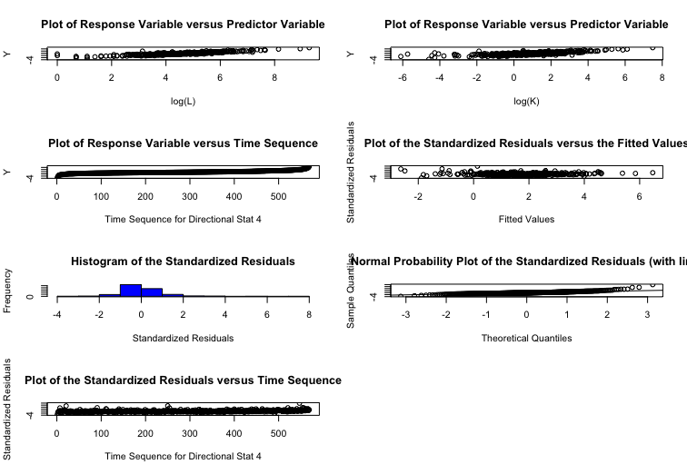# Resultados complementarios (no mostrados)  
# gvmodel.del <- deletion.gvlma(gvmodel)  
# summary(gvmodel.del)  
#  
# 'residuals' -errores estimados y `rstudent()` - residuos estudentizados  
# `densityPlot()` chequeo de la distribución de los errores (densidades estimadas)  
densityPlot(residuals(lm_cd))

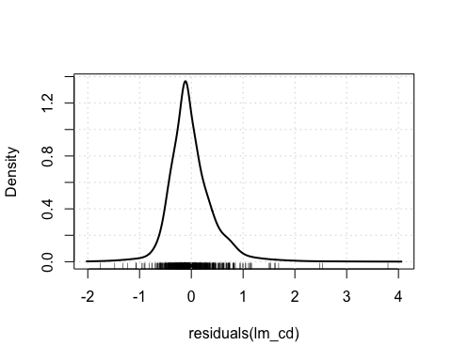

densityPlot(rstudent(lm_cd))

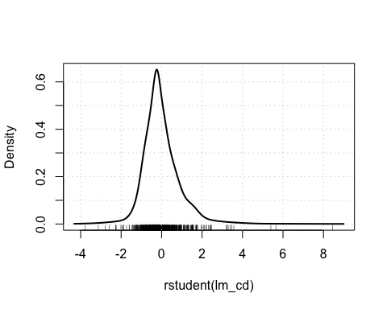

# `qqPlot()` chequeo de errores no-normales (comparación de los residuos estudentizados con una distribution t)  
qqPlot(lm_cd)

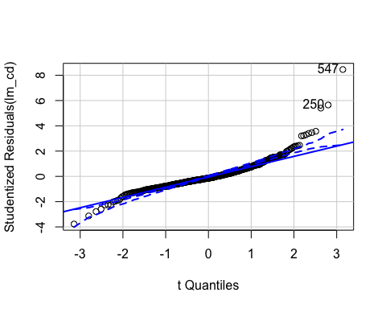

## [1] 250 547

#  
# Chequeo de 'outliers' en la regresión  
#  
max(hatvalues(lm_cd))

## [1] 0.07352641

which.max(hatvalues(lm_cd))

## 250   
## 250

#  
outlierTest(lm_cd)

## rstudent unadjusted p-value Bonferroni p  
## 547 8.453471 2.4146e-16 1.3739e-13  
## 250 5.647423 2.5824e-08 1.4694e-05  
## 21 5.400574 9.7990e-08 5.5757e-05

#  
max(cooks.distance(lm_cd))

## [1] 0.8000356

which.max(cooks.distance(lm_cd))

## 250   
## 250

#  
max(abs(dffits(lm_cd)))

## [1] 1.590946

which.max(abs(dffits(lm_cd)))

## 250   
## 250

#  
# Medidas de influencia

#  
S(influence.measures(lm_cd))

## Potentially influential observations of  
## lm(formula = log(Y) ~ log(L) + log(K), data = PROD_EMP) :  
##   
## dfb.1_ dfb.l(L) dfb.l(K) dffit cov.r cook.d hat   
## 1 -0.22 0.12 0.33 -0.59_* 0.96_* 0.11 0.02_*  
## 2 -0.21 0.19 -0.02 -0.25_* 1.01 0.02 0.02_*  
## 3 -0.03 0.02 0.04 -0.07 1.03_* 0.00 0.02_*  
## 4 -0.01 0.01 0.00 -0.02 1.02_* 0.00 0.01   
## 5 0.05 -0.04 0.02 0.05 1.03_* 0.00 0.02_*  
## 6 -0.04 0.03 0.00 -0.05 1.02_* 0.00 0.01   
## 7 0.15 -0.05 -0.42 0.64_* 0.99 0.13 0.04_*  
## 8 0.07 -0.07 0.03 0.08 1.02_* 0.00 0.02_*  
## 12 -0.01 0.01 0.00 -0.01 1.02_* 0.00 0.01   
## 15 0.01 -0.02 0.08 -0.09 1.02_* 0.00 0.01   
## 16 0.02 0.00 -0.08 0.12 1.02_* 0.00 0.02_*  
## 19 -0.21 0.19 -0.18 -0.24_* 0.96_* 0.02 0.01   
## 21 0.61 -0.49 -0.24 0.94_* 0.89_* 0.28 0.03_*  
## 43 -0.25 0.25 -0.27 -0.30_* 1.00 0.03 0.02_*  
## 91 0.14 -0.07 -0.23 0.41_* 0.96_* 0.05 0.01   
## 111 0.09 -0.05 -0.11 0.22_* 0.98_* 0.02 0.01   
## 142 -0.03 0.02 -0.07 -0.13 0.97_* 0.01 0.00   
## 158 -0.06 0.08 -0.12 0.13 1.02_* 0.01 0.02_*  
## 184 0.03 -0.03 0.03 0.03 1.02_* 0.00 0.01   
## 199 -0.22 0.27 -0.39 0.40_* 1.06_* 0.05 0.06_*  
## 210 0.03 -0.05 -0.03 -0.15 0.97_* 0.01 0.00   
## 250 1.52_* -1.54_* 1.26_* 1.59_* 0.92_* 0.80_* 0.07_*  
## 254 -0.14 0.22 -0.46 0.50_* 0.98_* 0.08 0.02_*  
## 267 0.11 -0.13 0.09 -0.16 0.98_* 0.01 0.01   
## 443 -0.26 0.31 -0.36 0.38_* 1.06_* 0.05 0.06_*  
## 457 0.02 -0.02 0.02 -0.03 1.02_* 0.00 0.01   
## 463 0.14 -0.13 0.14 0.18 0.98_* 0.01 0.01   
## 491 0.18 -0.19 0.05 -0.24_* 0.99 0.02 0.01   
## 521 0.14 -0.13 0.15 0.21 0.95_* 0.01 0.00   
## 534 0.03 -0.03 0.01 -0.03 1.02_* 0.00 0.01   
## 541 0.00 0.01 0.06 0.14 0.98_* 0.01 0.00   
## 547 0.14 0.01 -0.46 0.71_* 0.71_* 0.15 0.01   
## 549 0.00 0.00 0.01 0.01 1.02_* 0.00 0.01   
## 552 0.00 0.00 0.00 0.00 1.02_* 0.00 0.01   
## 553 -0.01 0.01 0.00 0.02 1.02_* 0.00 0.01   
## 554 -0.06 0.08 0.01 0.20 0.94_* 0.01 0.00   
## 557 -0.28 0.32 -0.24 0.35_* 0.96_* 0.04 0.01   
## 558 -0.03 0.04 0.00 0.05 1.02_* 0.00 0.01   
## 560 -0.03 0.03 0.01 0.05 1.02_* 0.00 0.01   
## 561 -0.09 0.09 -0.02 0.11 1.02_* 0.00 0.02   
## 562 0.02 -0.03 0.21 0.28_* 0.99 0.03 0.01   
## 563 -0.01 0.01 0.09 0.13 1.02_* 0.01 0.02_*  
## 566 -0.06 0.05 0.18 0.32_* 0.99 0.03 0.02_*  
## 567 -0.05 0.04 0.06 0.14 1.03_* 0.01 0.02_*  
## 568 -0.07 0.07 0.02 0.12 1.03_* 0.00 0.03_*  
## 569 -0.12 0.11 0.12 0.29_* 1.03_* 0.03 0.04_*

influenceIndexPlot(lm_cd, vars=c("hat", "Studentized","Cook"))

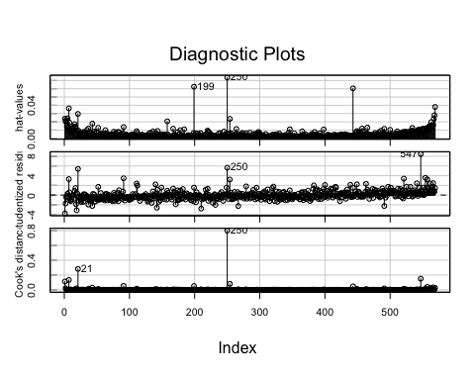

influencePlot(lm_cd, xlab="Hat values")

g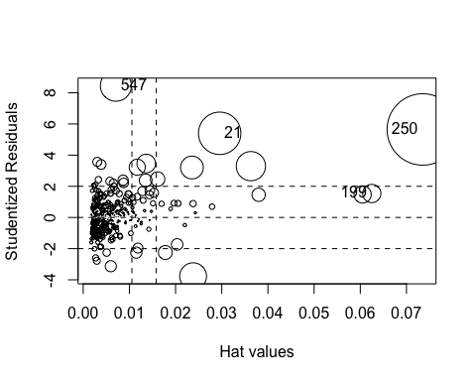

## StudRes Hat CookD  
## 21 5.400574 0.029552088 0.28202200  
## 199 1.537692 0.062489021 0.05240819  
## 250 5.647423 0.073526406 0.80003559  
## 547 8.453471 0.007080278 0.15105305

# Gráficos de variable añadida, buscando casos influyentes  
avPlots(lm_cd, id=list(cex=0.60, method="mahal"))

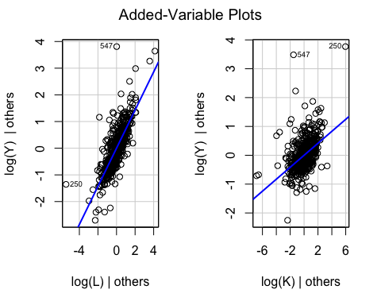

# Chequeo de no linealidad: gráficos de componente+residuo  
crPlots(lm_cd, smooth=list(span=0.7))

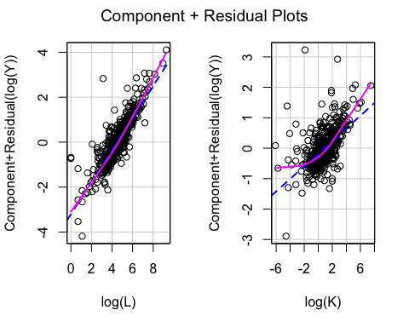

#  
ncvTest(lm_cd, var.formula= ~ log(L) + log(K))

## Non-constant Variance Score Test   
## Variance formula: ~ log(L) + log(K)   
## Chisquare = 115.8566, Df = 2, p = < 2.22e-16

#  
# Normalidad de los residuos  
# Distribución de los residuos  
r <- resid(lm_cd)  
rbar <- mean(r)  
sdr <- sd(r)  
rbar ; sdr

## [1] 2.55161e-17

## [1] 0.4772243

hist(r, col="grey", freq=FALSE, main="Distribución de los residuos",  
 ylab="Density", xlab="r")  
curve(dnorm(x, rbar, sdr), col=2, add=TRUE,  
 ylab="Density", xlab="r")

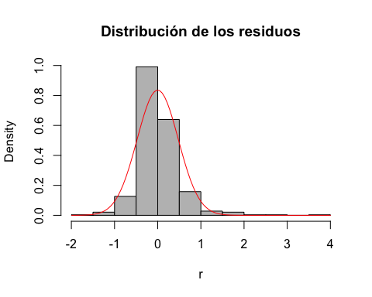

#   
# Residuos estandarizados  
rs<-((r-rbar)/sdr)   
hist(rs, freq=FALSE, main="Distribución de los residuos estandarizados",  
 ylab="Density", xlab="rs")  
curve(dnorm(x, 0, 1), col=2, add=TRUE,  
 ylab="Density", xlab="rs")

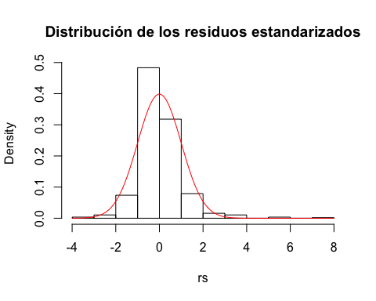

#  
qqnorm(rs)   
abline(0,1)

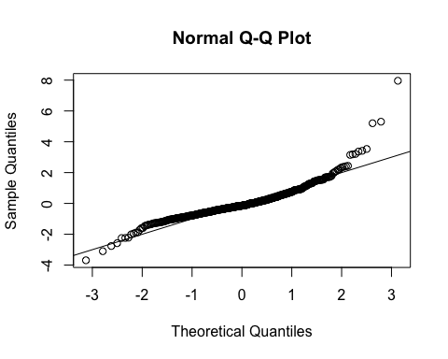

#  
jarque.bera.test(r) #(package 'tseries')

##   
## Jarque Bera Test  
##   
## data: r  
## X-squared = 2677.3, df = 2, p-value < 2.2e-16

shapiro.test(r)

##   
## Shapiro-Wilk normality test  
##   
## data: r  
## W = 0.88577, p-value < 2.2e-16

#  
# Distribución de los residuos estudentizados  
#   
n <- nobs(lm_cd)  
k <- n-df.residual(lm_cd)  
n ; k

## [1] 569

## [1] 3

rt <- studres(lm_cd)  
hist(rt, freq=FALSE,  
 main="Distribución de los residuos estudentizados")  
xfit<-seq(min(rt),max(rt),length=40)  
yfit<-dt(xfit,n-k-2)  
lines(xfit, yfit)

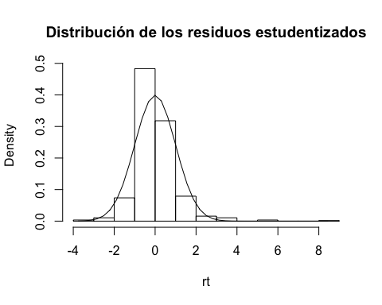

# QQ plot de los residuos estudentizados  
qqPlot(lm_cd, main="QQ Plot")

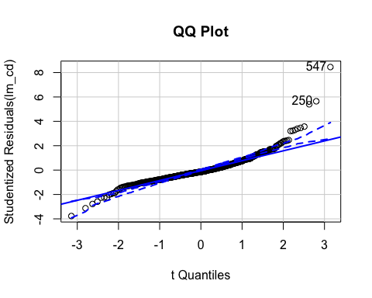

## [1] 250 547

# No linealidad  
# Component+R plots  
crPlots(lm_cd)

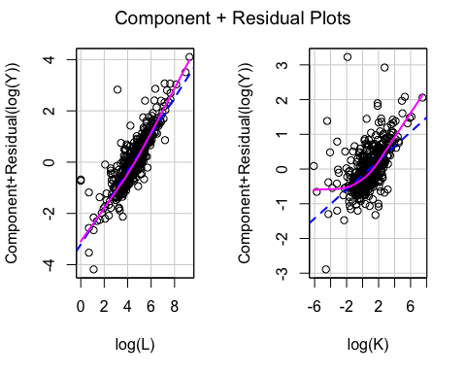

# Ceres plots  
ceresPlots(lm_cd)

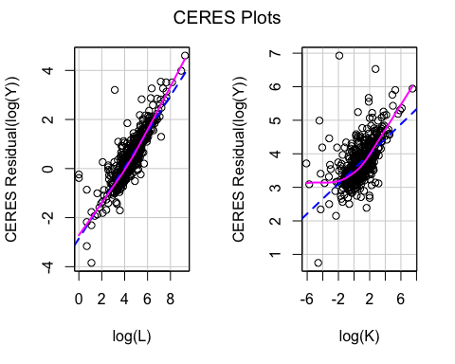

# Test RESET  
resettest(lm_cd, power=2, type="fitted")

##   
## RESET test  
##   
## data: lm_cd  
## RESET = 46.587, df1 = 1, df2 = 565, p-value = 2.266e-11

resettest(lm_cd, power=2:3, type="fitted")

##   
## RESET test  
##   
## data: lm_cd  
## RESET = 24.493, df1 = 2, df2 = 564, p-value = 6.303e-11

#  
# Chequeo de varianza no constante: heteroscedasticidad  
r2 <- resid(lm_cd)^2  
yhat <- fitted(lm_cd)  
l_L <- log(PROD_EMP$L)  
l_K <- log(PROD_EMP$K)  
plot(l_L,r2, xlab="Empleo", ylab="r^2")

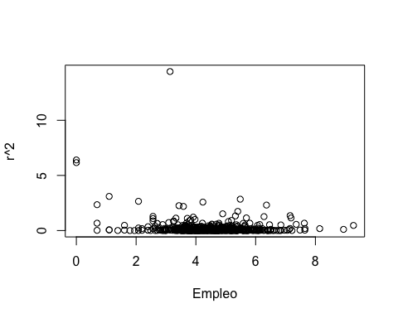

plot(l_K,r2, xlab="Stock de capital", ylab="r^2")

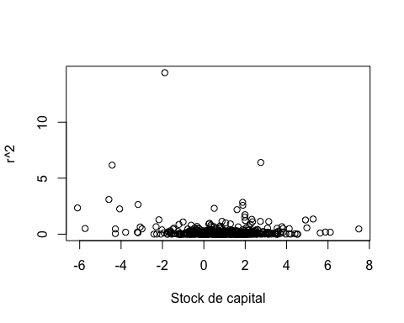

#  
plot(yhat,r2, xlab="Valores estimados", ylab="r^2")

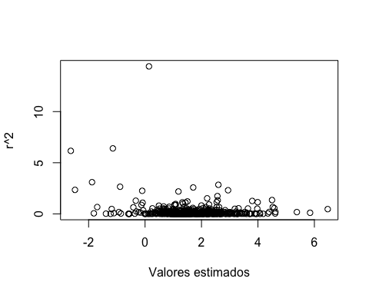

#  
spreadLevelPlot(lm_cd)

## Warning in spreadLevelPlot.lm(lm_cd):   
## 28 negative fitted values removed

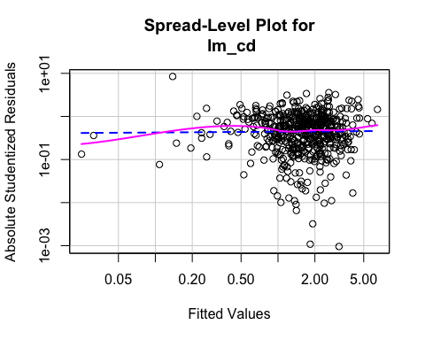

##   
## Suggested power transformation: 0.9813464

#  
ncvTest(lm_cd)

## Non-constant Variance Score Test   
## Variance formula: ~ fitted.values   
## Chisquare = 113.3136, Df = 1, p = < 2.22e-16

ncvTest(lm_cd, ~ log(L) + log(K) + I((log(L))^2) + I((log(K))^2) + I(log(L)*log(K)) ) # Test de White (score test)

## Non-constant Variance Score Test   
## Variance formula: ~ log(L) + log(K) + I((log(L))^2) + I((log(K))^2) + I(log(L) * log(K))   
## Chisquare = 491.2026, Df = 5, p = < 2.22e-16

ncvTest(lm_cd, ~ log(L) + log(K) ) # Test de Breusch-Pagan (las variables Zs pueden ser externas al modelo) (score test)

## Non-constant Variance Score Test   
## Variance formula: ~ log(L) + log(K)   
## Chisquare = 115.8566, Df = 2, p = < 2.22e-16

#  
bptest(lm_cd) # Breusch-Pagan robusto (variante robusta de Koenker)

##   
## studentized Breusch-Pagan test  
##   
## data: lm_cd  
## BP = 19.237, df = 2, p-value = 6.647e-05

bptest(lm_cd, studentize = FALSE) # Breusch-Pagan estándar (escalado)

##   
## Breusch-Pagan test  
##   
## data: lm_cd  
## BP = 115.86, df = 2, p-value < 2.2e-16

bptest(lm_cd, studentize = FALSE, varformula = ~ log(L), data = PROD_EMP ) #

##   
## Breusch-Pagan test  
##   
## data: lm_cd  
## BP = 115.18, df = 1, p-value < 2.2e-16

#  
# Corrección de la heteroscedasticidad  
#  
# Errores estándar (SEs) robustos  
S(lm_cd, vcov.=hccm(lm_cd, type = "hc1")) # hc1 (corrección de White)

## Call: lm(formula = log(Y) ~ log(L) + log(K), data = PROD_EMP)  
## Standard errors computed by hccm(lm_cd, type = "hc1")   
##   
## Coefficients:  
## Estimate Std. Error t value Pr(>|t|)   
## (Intercept) -1.71146 0.17500 -9.780 < 2e-16 ***  
## log(L) 0.71485 0.04137 17.279 < 2e-16 ***  
## log(K) 0.20757 0.03025 6.862 1.78e-11 ***  
## ---  
## Signif. codes: 0 '***' 0.001 '**' 0.01 '*' 0.05 '.' 0.1 ' ' 1  
##   
## Residual standard deviation: 0.4781 on 566 degrees of freedom  
## Multiple R-squared: 0.8378  
## F-statistic: 510.4 on 2 and 566 DF, p-value: < 2.2e-16   
## AIC BIC   
## 779.89 797.27

#  
# Modelo translog  
#  
S(lm_tl <- lm(log(Y) ~ log(L) + log(K) + I((log(L))^2) + I((log(K))^2) + I(log(L)*log(K)), data = PROD_EMP))

## Call: lm(formula = log(Y) ~ log(L) + log(K) + I((log(L))^2) + I((log(K))^2) +  
## I(log(L) * log(K)), data = PROD_EMP)  
##   
## Coefficients:  
## Estimate Std. Error t value Pr(>|t|)   
## (Intercept) -0.957857 0.211377 -4.531 7.16e-06 ***  
## log(L) 0.315355 0.100434 3.140 0.001779 **   
## log(K) 0.359393 0.053041 6.776 3.13e-11 ***  
## I((log(L))^2) 0.047207 0.012236 3.858 0.000128 ***  
## I((log(K))^2) 0.035384 0.006159 5.745 1.50e-08 ***  
## I(log(L) * log(K)) -0.043268 0.012381 -3.495 0.000512 ***  
## ---  
## Signif. codes: 0 '***' 0.001 '**' 0.01 '*' 0.05 '.' 0.1 ' ' 1  
##   
## Residual standard deviation: 0.4478 on 563 degrees of freedom  
## Multiple R-squared: 0.8585  
## F-statistic: 683.1 on 5 and 563 DF, p-value: < 2.2e-16   
## AIC BIC   
## 708.35 738.76

S(lm_tl, vcov.=hccm(lm_tl, type = "hc1")) # hc1 (corrección de White)

## Call: lm(formula = log(Y) ~ log(L) + log(K) + I((log(L))^2) + I((log(K))^2) +  
## I(log(L) * log(K)), data = PROD_EMP)  
## Standard errors computed by hccm(lm_tl, type = "hc1")   
##   
## Coefficients:  
## Estimate Std. Error t value Pr(>|t|)   
## (Intercept) -0.957857 0.400962 -2.389 0.01723 *   
## log(L) 0.315355 0.188766 1.671 0.09535 .   
## log(K) 0.359393 0.111510 3.223 0.00134 **   
## I((log(L))^2) 0.047207 0.022171 2.129 0.03367 *   
## I((log(K))^2) 0.035384 0.008899 3.976 7.92e-05 ***  
## I(log(L) * log(K)) -0.043268 0.024302 -1.780 0.07554 .   
## ---  
## Signif. codes: 0 '***' 0.001 '**' 0.01 '*' 0.05 '.' 0.1 ' ' 1  
##   
## Residual standard deviation: 0.4478 on 563 degrees of freedom  
## Multiple R-squared: 0.8585  
## F-statistic: 593.8 on 5 and 563 DF, p-value: < 2.2e-16   
## AIC BIC   
## 708.35 738.76